New Consent Decree Jeopardizes Sustainability of Great Lakes fishery Resources and the Fishers that Depend on Them.
Jim Johnson
Coalition to protect Michigan Resources
December 2022
Introduction
The newly signed Consent Decree between the State of Michigan, the United States, and the four of the five tribes of the Treaty of 1836 represents a huge step backward in protection and stewardship of Michigan’s fragile Great Lakes fisheries.
The State of Michigan, in negotiating this Decree, abandoned the initiative emphasized of the 2000 Consent Decree to replace the destructive, lethal, gillnet commonly fished by the tribes with more selective and far less lethal trapnets. In so doing, the new Decree opens vast reaches of Lake Superior that were, until now, trapnetting and recreational fishing zones to gillnetting. Gillnetting “opportunities” have been expanded in lakes Michigan and Huron. In Lake Huron, the new Decree even opens a lake trout spawning refuge to gillnetting. This refuge, which until now was closed to gillnets and the harvest of lake trout, given refuge status by the Canadian and US biologists that coordinate their activities on Lake Huron under the aegis of the Great Lakes Fishery Commission. Another refuge, the Northern Lake Michigan Refuge, is surrounded by waters suffering from effects of overfishing and which will now experience even more nets. Lake trout were exterminated from lakes Huron and Michigan by overfishing and sea lamprey depredation. They are still dependent on stocking in Lake Michigan, and are staging a fragile recovery in Lake Huron; lake trout cannot sustain such increases in fishing pressure. Recreational fishing and trapnet zones designated by the previous consent decree had afforded lake trout protection from the impacts of gillnets and, thus, were centers for lake trout recovery. These zones are vastly diminished, and gillnets will now be allowed in many of these areas.
This unleashing of fishing pressure is seriously at odds with the biological capacity of lakes Huron and Michigan. These two lakes are suffering from the devastating effects of invasive zebra and quagga mussels and continue to struggle with the toll taken by the invasive sea lamprey. Yet, the parties negotiating the new consent decree have done just the opposite of what is needed to protect the resource, significantly increasing fishing “opportunities” in all three lakes. Whitefish in most areas of northern lakes Huron and Michigan have already collapsed to near economic extinction. If lake trout also collapse, most types of fishing activities will prove unsustainable. The ancient heritage of subsistence fishing, and commercial and recreational fishing as well, will be threatened, along with the economic and cultural wellbeing of families and businesses that have engaged in fishing for generations.
The biological setting
The lakes tell us, in no uncertain terms, that fishing needs be carefully and conservatively managed to maintain balance between harvest and the new reality of shrinking fishing resources imposed in recent decades by a wave of invasive species.
The foodweb was irrevocably altered when two species of dreissenid (zebra and quagga) mussels invaded the Great Lakes via ballast water of salt-water-going cargo ships, which in turn had gained access to the Great Lakes by the St. Lawrence Seaway around Niagara Falls. During the 1990s, both species of mussels colonized all the Great Lakes, but with only limited success in Lake Superior. (Superior water is too “soft,” lacking sufficient calcium for the mussels to build shells, and too cold for zebra mussels.) Soon followed a cigar-sized, bottom-dwelling fish, the round goby. All three species are of Caspian origin.
The first documented casualty of the mussel invasion was the shrimp-like bottom dwelling Diporeia, which until about 2000, had been the dietary staple of lake whitefish. Today, Diporeia are nearly absent from lakes Huron and Michigan. Although the exact cause of the Diporeia collapse remains unclear, both Diporeia and dreissenid mussels are filter feeders; that is, they feed on tiny particles, mostly suspended algae and detritus. The filtering efficiency of enormous numbers of dreissenids may have worked to the detriment of Diporeia. Zooplankton, very small planktonic animals that feed on phytoplankton (the suspended algae) declined almost simultaneously with the collapse of Diporeia, evidently also a victim of dreissenid filtering. Zooplankton are essential for survival of fry of certain species that hatch at very small sizes, and thus have small mouth openings, whitefish and walleye for example. The enormous number of mussels has redirected productivity from the water column (plankton) to the bottom (mussels and other bottom-dwelling vegetation and invertebrates). As a result of this “dreissenid reengineering” of nutrient pathways, nutrients in the nearshore zone tend to be sequestered in the form of periphytic (attached to lake bottom) filamentous algae and benthic invertebrate biomass such as mussels and insects which are not available to larval fish with small mouth gapes. Lake whitefish reproduction in most of the northern portions of the two lakes reached critically low levels and by 2015 the lack of reproduction was evidenced by sharply declining catches (see appended Figures 1 and 2). The planktivorous mid-water alewife, upon which chinook salmon depend for food, almost disappeared from Lake Huron by 2005 and declined sharply in Lake Michigan; thus, the decline in zooplankton has far-reaching implications to the fish community.
Two foundational assumptions at the time of execution of the 2000 Consent Decree were that: a) robust Chinook salmon populations would be the mainstay of recreational fishing in both lakes Huron and Michigan; and b) a vibrant commercial fishery for lake whitefish, which had reached record-high harvest levels at the time of signing, would sustain the commercial and tribal subsistence fisheries for the foreseeable future.
The signers of the 2000 Consent Decree could not have imagined how swiftly and thoroughly their vision for the future would be reversed. By 2006, Lake Huron’s Chinook salmon were all but gone and Lake Michigan’s salmon were in decline. Presently, whitefish catches are so low in some units that commercial fishers are seeking other species to sustain their businesses.
Such a steep decline in the resource represents a crisis for not only the resource but the fishers that depend upon it. As opportunity to harvest whitefish declined, fishers have been shifting their targets to lake trout, but lake trout in lakes Michigan and Huron are not yet recovered from their local extinctions caused by a combination of sea lamprey depredation and overfishing. Efforts to restore lake trout in the Great Lakes constitute one of North America’s largest-scaled keystone predator recovery projects. In the late 1950s, the Great Lakes Fishery Commission implemented a sea lamprey control program for the Great Lakes. Restocking of lake trout in Lake Huron began in the 1970s. It is important to recognize that avoiding any overfishing during recovery is essential to rehabilitation of this species. Similarly, walleye and yellow perch fisheries, particularly in Big and Little Bays de Noc, have suffered declines since 2000 and cannot sustain targeting by commercial fishing.
Healthy fish populations are the foundation of sustainable fishing, whether commercial or recreational; in other words, sustainable fishing opportunity can only be had with stable fish populations. To assure sustainability, the parties must recognize the dramatic reductions in the fish populations of lakes Michigan and Huron and squarely address the diminished state of the fishery by balancing harvest with today’s reduced capacity of the fish community.
The parties, therefore, must recognize the decreased availability of the leading target species for recreational (salmon) and commercial (whitefish) fishing since 2000. The appropriate biological response, in light of these changes, is to take a conservative approach in a new decree that protects the diminished whitefish stocks from overharvest while taking precautionary measures to protect lake trout and walleye as the focus of fishing shifts to these recovering native species. Recognition of these biological realities should have been the basis of negotiations for a renewed consent decree.
New Decree Ignores Reality of a Diminished Resource
Contrary logic and the direction supported by biology, the parties have barely considered the changed trophic state of the lower two lakes and have, instead, been seeking “increased opportunities” to harvest whitefish, lake trout, walleye, and yellow perch. The 2000 Consent Decree, in an effort to reduce mortality of nontarget species such as lake trout, directed $14 million to converting nonselective, lethal gillnets to more selective trapnet fisheries. This conversion project has been abandoned in current negotiations. In a huge step backward, expansive new gillnetting opportunities that will increase fishing pressure have been agreed to.
“Zone Management”, which in the 1985 and 2000 Consent Decrees had protected recreational zones and lake trout refuges from gillnetting, has also been much diminished. Recreational zones would be greatly reduced, and one refuge would be opened to gillnetting. Gillnet fishing proposed for the present recreational zone of Bays de Noc will further shrink the walleye and yellow perch populations there and jeopardizes the most important recreational fishing area of Michigan’s Upper Peninsula. And most recreational and trapnet zones in Lake Superior, designated by the 2000 Decree, will disappear.
Lake trout spawning refuges have been designated in northern lakes Michigan and Huron by inter-jurisdictional actions of the Great Lakes Fishery Commission Lake Committees. These refuges are designed to help protect recovering stocks from overfishing by prohibiting lake trout harvesting in the vicinity of historically important spawning areas. A combination of the Drummond Island Refuge designation, the 2000 Consent Decree gillnet-to-trapnet conversion project, and millions of dollars in lake trout stocking and heightened sea-lamprey control, particularly in the St. Marys River, have contributed to rehabilitation of spawning lake trout in northern Lake Huron. Spawning in northern Lake Huron appears to be supporting lake trout throughout the lake. Since the collapse of alewives, lake trout stocking no longer is deemed economically viable. Thus, the proposal to open the Drummond Island Refuge to gillnetting is a unilateral action, unsanctioned by other Great Lakes Fishery Commission member agencies, that is likely to undermine progress to date in lake trout rehabilitation in Lake Huron. It is unlikely the agencies can “stock their way out” of a second collapse of lake trout in Lake Huron as long as stocking continues to be ineffective. Lake Michigan’s northern refuge will be surrounded by heightened gillnetting, almost assuring that mortality rates will exceed those necessary for restoration of lake trout. The spawning refuge will, consequently, be almost devoid of lake trout old enough to spawn and the commercial fishery will continue to be supported by “put-grow-take” stocking and millions of dollars annually in fish hatchery costs.
Gillnetting compromises other Great Lakes fish populations, including lake sturgeon. Lake sturgeon number less than 1% of historical levels (Ed Baker: https://www.michiganradio.org/environment-science/2020-08-11/dead-sturgeon-found-on-lake-michigan-beaches), are State-listed as “threatened” in Michigan, and a federal court has ordered the U.S. Fish and Wildlife Service to make a determination by 2024 whether imperiled populations of lake sturgeon will be protected under the Endangered Species Act. Restoration stocking of lake sturgeon began in Bays de Noc in 2006 and these stocked fish are relatively young, meaning they are of sizes to be vulnerable to the 4.5-inch gillnets most commonly fished for lake whitefish. Gillnets are non-selective, and their catch is often dead or moribund when landed. Thus, it is important to protect sturgeon rehabilitation sites from commercial gillnetting.
A more detailed review of the status of lake trout, walleye, and yellow perch is appended.
The proposed measures, if implemented in the new Consent Decree, will not only further destabilize fish populations and compromise sustainability of commercial fisheries, but they will also undermine recreational fishing and allocate almost all harvest in 1836 Treaty Waters to tribal fishers. Because lake trout and whitefish are slow growing and long-lived, a collapse of these species would take at least 10 years for even partial recovery to be realized. A decade of lost fishing opportunity would mean economic extinction of fishing industries and livelihoods.
Measures that could mitigate effects of invasive species and foodweb change—and thus, support natural reproduction and the viability of fishing stocks The new agreement should foster an informed community of resource users: Recreational and commercial fishers are often the most vocal and effective advocates for resource stewardship. It was commercial fishers that most effectively advocated for sea lamprey control during the 1940s and 1950s. The finding of chlorinated hydrocarbon contamination of salmon during the 1970s marshalled a successful advocacy, led by recreational fishers, for banning of DDT and PCBs. Informed fishers can foster support for sustainable management of fishery resources; therefore, a wise beginning to the negotiation of a new decree would have been outreach to the fishing communities with the objective of sharing with the fishers the constraints imposed upon fishing opportunity by invasive-species-triggered foodweb changes (largely negative on available fishing stocks). But the negotiations have been conducted in secret, under a “nondisclosure agreement” among the parties, and the fishers and other potential resource stewardship advocates were, until its recent public release, not aware of any provisions of the agreement.
A shared understanding of resource conditions would also have laid a foundation of common understanding regarding causes of declining whitefish stocks and set the stage for discussion of needed research into corrective measures, such as whether restocking whitefish might restore some of the lost whitefish production. A shared understanding of the cause of recent declines in whitefish stocks and the tenuous status of lake trout in lakes Huron and Michigan would also have helped to establish realistic expectations for future fishing opportunities. Only with a shared understanding of the depleted and fragile state of fish populations will regulation of the resource be met with widespread acceptance by its users.
Resource management strategies and harvest regulation: Given the disastrous collapse of whitefish stocks in most waters of Lake Michigan and northern Lake Huron, the resource agencies must take a precautionary approach to future harvest management. The management framework set forth in a new decree must be based on this cautionary approach.
The parties (agencies and fishers) need to recognize that there are few, if any, opportunities for increasing harvest of either whitefish or lake trout in lakes Huron and Michigan. Because both lake trout and whitefish now feed on the invasive round goby, and round gobies prefer rocky substrates, the gillnet fishery is now likely to focus on such substrates; this will increase the bycatch of lake trout in gillnets targeting whitefish. In many areas of these lakes, whitefish numbers are so low that gillnet fisheries are purposefully targeting lake trout. Thus, considering the tenuous status of lake trout recovery in both lakes Huron and Michigan and the recovery efforts for the threatened lake sturgeon, it would be prudent for the parties to continue with the conversion of gillnet to trapnet effort initiated with the 2000 Decree.
Mortality of lake trout is above target levels in MM-1,2,3 (Northern Lake Michigan) and MM-4 (Traverse Bay). While below-target levels now prevail in other Huron and Michigan units, any rise in lake trout bycatch in gillnets and any increase in gillnet targeting of lake trout would threaten status of those stocks as well.
A cautionary approach that should protect these recovering stocks of lake trout would include:
- Continuing the effort initiated by the 2000 Consent Decree to convert the nonselective, more lethal gillnet to trapnet effort. This would have the added advantage of protecting lake sturgeon and other non-target species.
- Prescribing lake trout total mortality rates that are below 40% for all lake trout management units and whitefish total mortality rates below about 45%. Mortality targets specified by the 2000 Decree have been eliminated and the setting of targets are now assigned to the TFC and Modeling Subcommittee, leaving this critical decision unresolved.
- Recognizing that performance for the 13 working whitefish models was recently rated as “high” for just one of them, with the remainder rated as “medium” or “low.” With changing growth, longevity, diets, distribution, and gear selectivity, models need to be continually updated and, even if they are, they lag behind real-time events in the fisheries. Estimation of recruitment is especially inexact. Given these uncertainties, a conservative approach to harvest estimation would be appropriate. Presently, harvest is estimated based upon maximum sustainable mortality rates, which leaves no room for error. Under such “maximum sustainable yield” approaches any overestimations of allowable harvest can compromise sustainability of the resource. Allowing a “buffer” to shield the resource from harvest estimation error should be routine given the instability of the Huron and Michigan fisheries.
- Recognizing that the commercial fishers are shifting from the diminishing whitefish, and recreational fishers from salmon to lake trout fishing and, accordingly, tak precautionary measures. Such measures would include reviewing commercial harvest and recreational bag limits annually, as has been almost routine since the 2000 Decree; maintaining the trapnet and recreational fishing zones from the 2000 Decree as gillnet-free zones, reducing the number of zones where gillnets may be fished, and limiting entry of new gillnet effort by management unit.
- Using zone management to protect especially valuable habitats or vulnerable aggregations of fish and to protect opportunities for recreational and trapnet fishers to realize their allocation of the resource.
- Continuing to protect lake trout refuges from lake trout fishing. Refuges are one type of zone management that protect locations considered by the agencies to be the most productive spawning habitats. These refuges are important to the lakes-wide management and recovery of lake trout.
- Protecting large, vulnerable aggregates of lake trout during spawning season. The current spawning closure defined by the 2000 Decree is November 7-November 29. Most lake trout spawn in lakes Michigan and Huron beginning in mid-October and continuing until about November 20. Thus, lake trout are presently not protected during the height of their spawning and are extremely vulnerable to harvest during late October and early November.

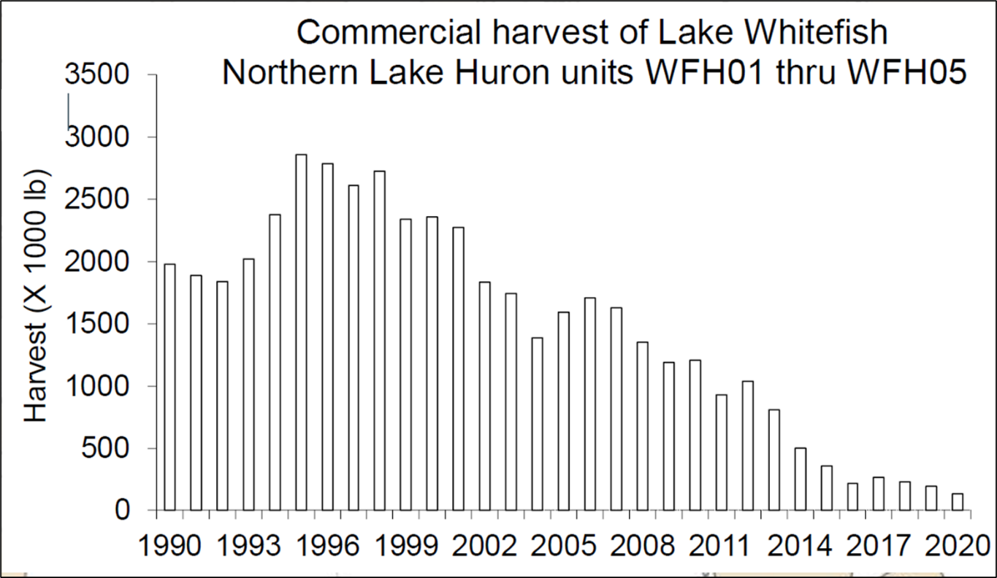
Figure 1. Commercial harvest of lake whitefish from northern units (1836 Treaty Waters) of Lake Huron, from Lenart (2022).
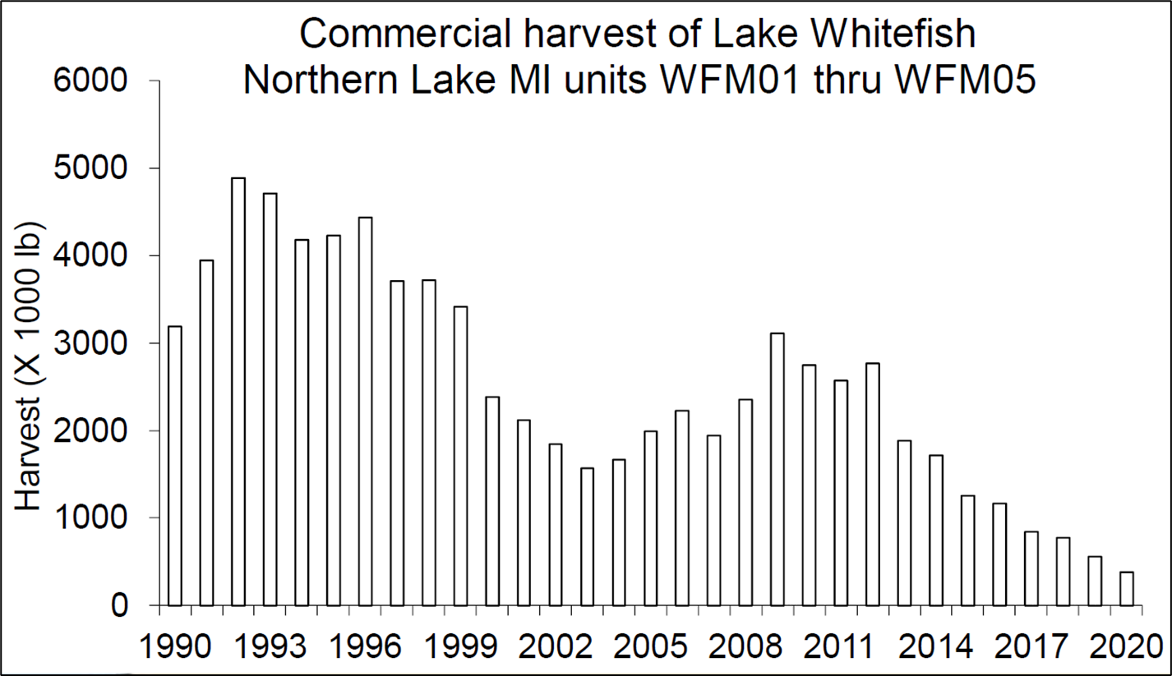
Figure 2. Commercial harvest of lake whitefish from northern whitefish management units of Lake Michigan, from Lenart (2022).

